Manual Strategy Report

Machine Learning for Trading

Abstract

This project is to train the stock shares using technical indicators, manual strategy with trial and error limiting points and best possible strategy.

Indicators

Simple moving average

For technical indicators, simple moving average (SMA), Bollinger Bands (BB) and momentum are selected for this manual strategy assignment. The simple moving average window size is taken into account of 20 days and the mean values are used for simple moving average indicator. The graph is as shown below.

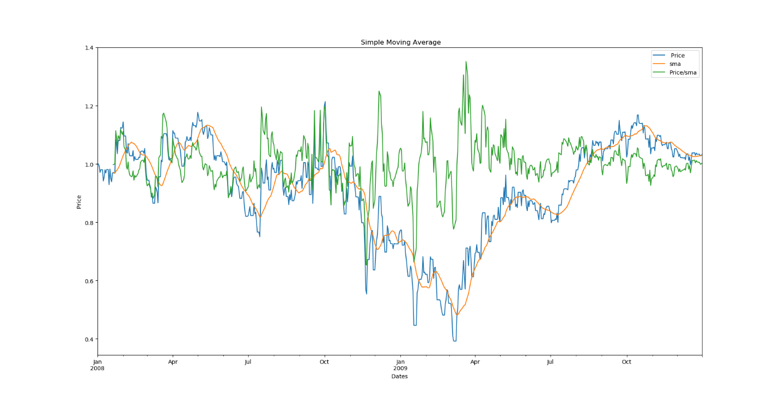

Bollinger Bands

Bollinger band has upper and lower bounds to observe the price going back to its average moving price. The theory states that when the price is out of the bounds, the price would move back to its origin average price. The bands are calculated with the difference between price and simple moving average divided by twice of the standard deviation values.

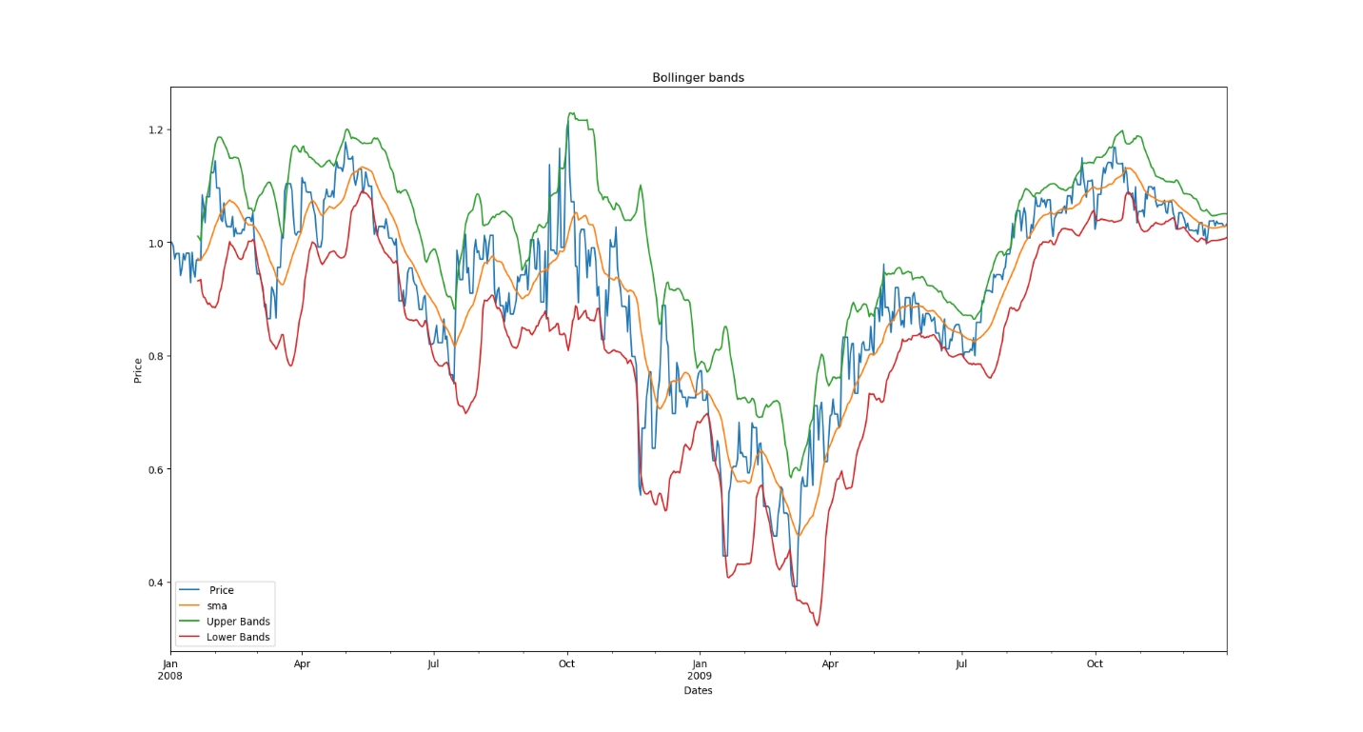

Momentum

Momentum predicts if the price should keep going up or down with its inertia movement. The momentum is evaluated using price / price.shift where price needs to be normalized.

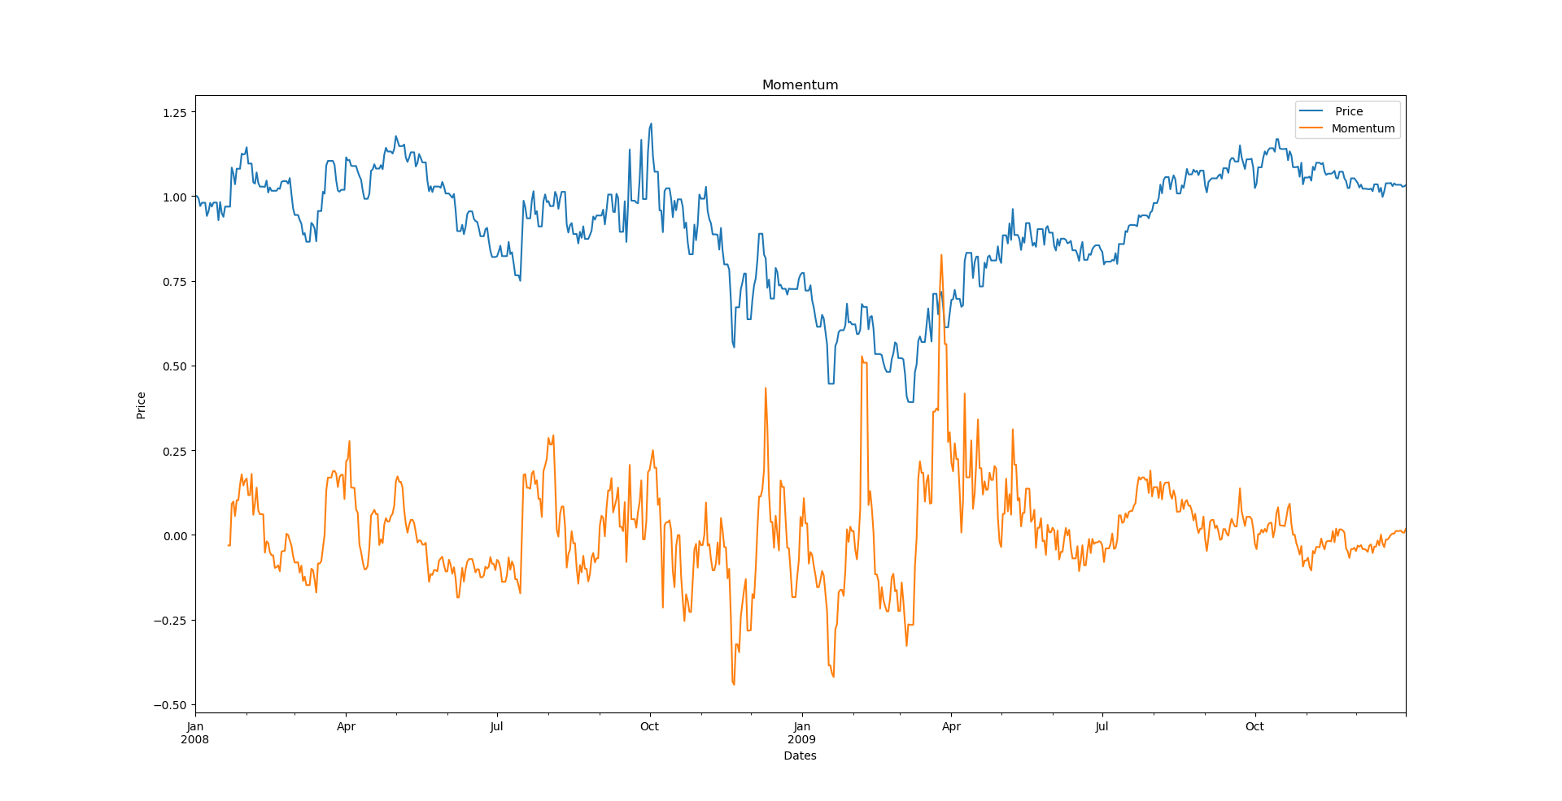

Best possible strategy

To calculate the best profit, the future is peeked with the stock price low or high consideration. The final value of stock holding is 0 or -1000, then the stock should be long assuming the future price is higher than current one. When the future price is lower, the final value of stock holding is 0 or +1000.

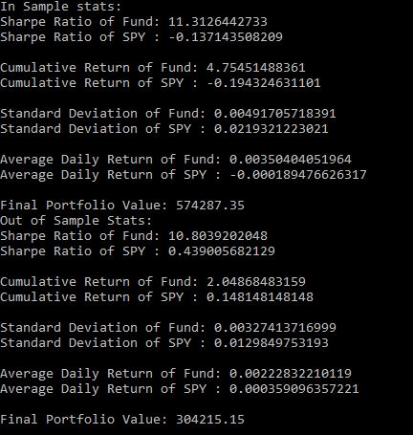

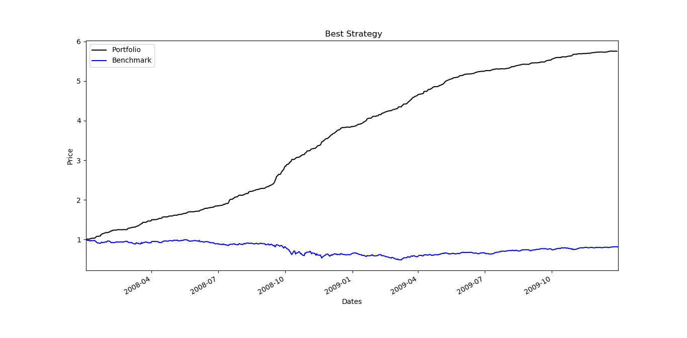

Manual Strategy

The manual strategy is calculated taking consideration the weights of the Bollinger Bands (BB) and momentum. The stock should be long when the momentum is lower than 5% , BB is lower than 15% and final value holding is 0/ -1000. The stock should be short if the opposite condition applies.

